# Clean-Data-Coursera

# Github repository with script for performing the analysis on data collected from the accelerometers from the Samsung Galaxy # S smartphone.

#

# Coursera Data Cleaning Course

# Assignment: Getting and Cleaning Data Course

# Purpose

# Create one R script called run_analysis.R that does the following.

# 1 - Merges the training and the test sets to create one data set.

# 2- Extracts only the measurements on the mean and standard deviation for each measurement.

# 3 - Uses descriptive activity names to name the activities in the data set

# 4 - Appropriately labels the data set with descriptive variable names.

# 5-From the data set in step 4, creates a second, independent tidy data set with the average of each variable for each

# activity and each subject.

#

###################################################################

# Data for the project:

# https://d396qusza40orc.cloudfront.net/getdata%2Fprojectfiles%2FUCI%20HAR%20Dataset.zip

#

# install.packages("dplyr")

library(dplyr)

#

# Attaching package: 'dplyr'

# The following objects are masked from 'package:stats':

#

# filter, lag

# The following objects are masked from 'package:base':

#

# intersect, setdiff, setequal, union

###################################################################

# Step 1

## Downloading the data

## Directory ".MMB_data' as working directorysetwd(cur_dir)

> cur_dir<-"./MMB_Data"

> if(!dir.exists("./MMB_Data")) dir.create("./MMB_Data")

> setwd(cur_dir)

# Checking if archieve already exists.

file_data<-"Coursera_CD.zip"

dir_cur<-"./MMB_Data"

if (!file.exists(file_data)){

fileURL <- "https://d396qusza40orc.cloudfront.net/getdata%2Fprojectfiles%2FUCI%20HAR%20Dataset.zip"

download.file(fileURL, file_data, method="curl")

}

# Unziping file

if (!file.exists("UnZip_Dataset")) {

unzip(file_data)

# Giving names for data frames

features_name<-read.delim ("UCI HAR Dataset/features.txt", header = FALSE, col.names = 'features')

View(features_name)

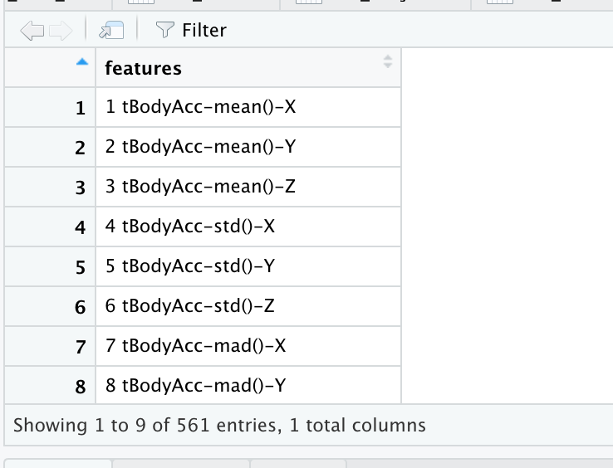

# Transform feature_name to vector to rename train_feature columns

features_name<-as.vector(features_name[,1])

# Giving names for TRAIN data frames

train_label<-read.delim("UCI HAR Dataset/train/y_train.txt", header = FALSE, col.names = 'train_label')

View(train_label)

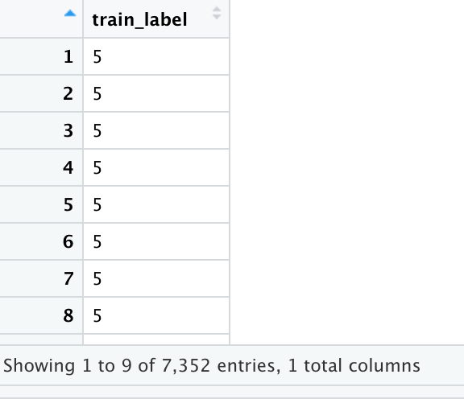

train_subject<-read.delim ("UCI HAR Dataset/train/subject_train.txt", header = FALSE, col.names = 'train_subject')

View(train_subject)

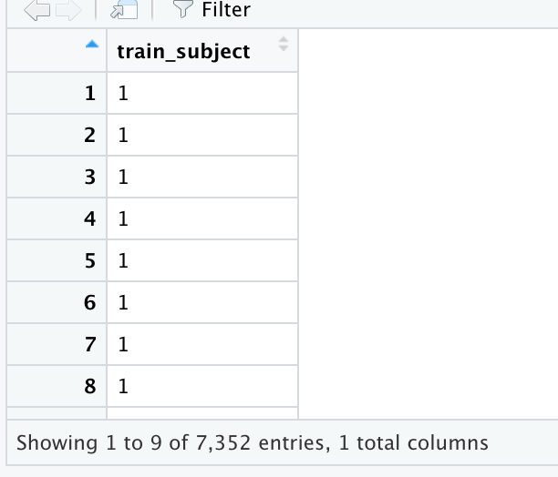

# Creating the data frame with TRAIN label and subject

train_data <- data.frame (train_label, train_subject)

View(train_data)

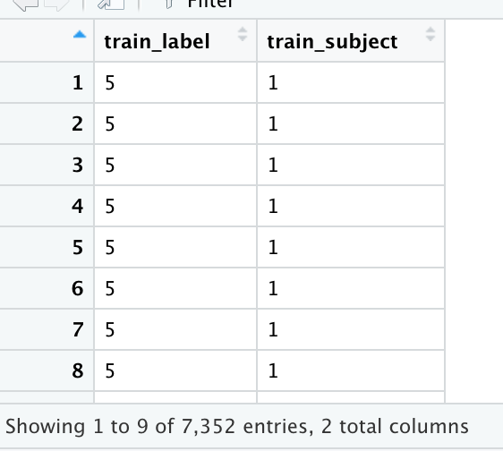

# Creating a data frame with all 7352 TRAIN entries for the 561 features

train_features<-read.delim("UCI HAR Dataset/train/X_train.txt", header = FALSE, sep = "")

>View(train_features)

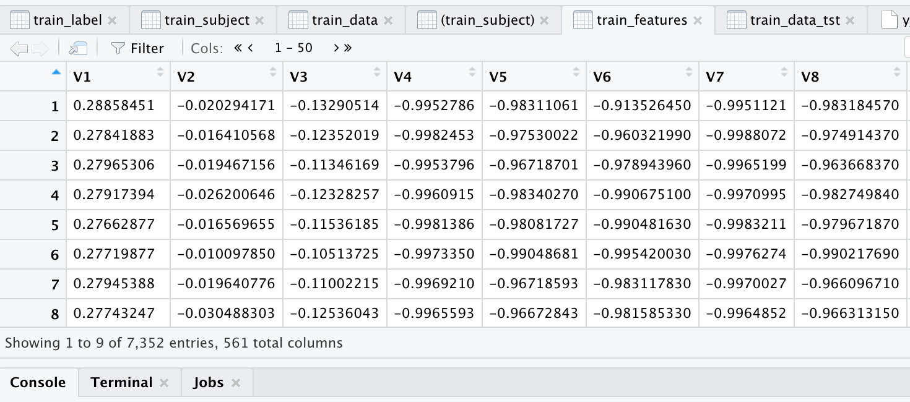

# Rename train_features column_names with feature_names

for(i in 1:561){

names(train_features)[names(train_features) == colnames(train_features[i])]<-features_name[i]

}

View(train_features)

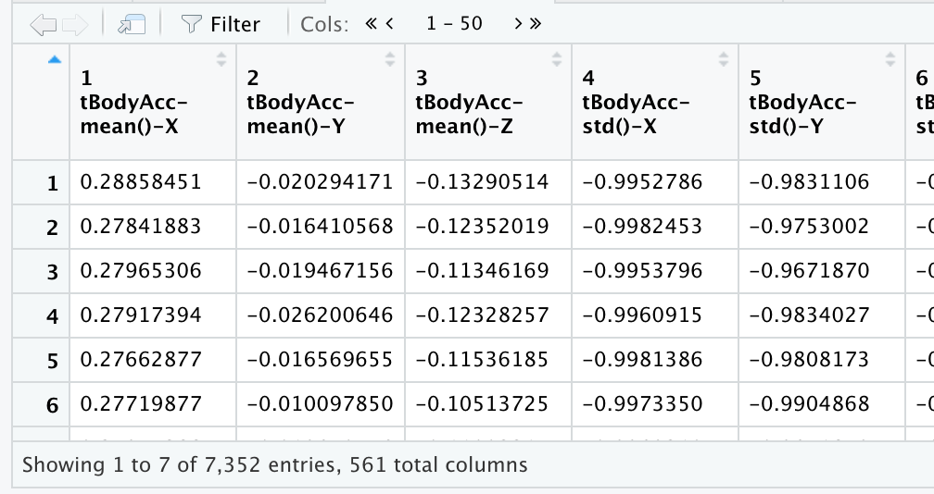

# Giving names for TEST data frames

test_label<-read.delim("UCI HAR Dataset/test/y_test.txt", header = FALSE, col.names = 'test_label')

View(test_label)

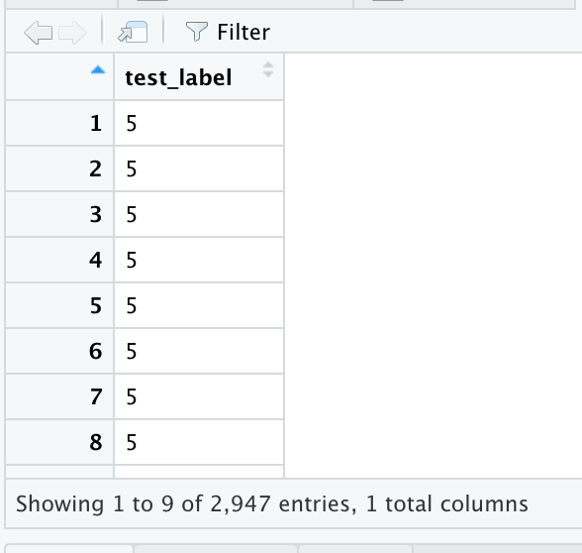

test_subject<-read.delim("UCI HAR Dataset/test/subject_test.txt", header = FALSE, col.names = 'test_subject')

View(test_subject)

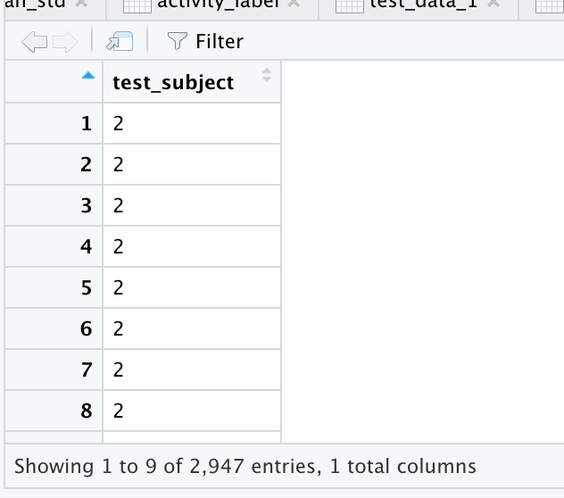

# Creating the data frame with TEST label and subject

test_data <- data.frame (test_label, test_subject)

View(test_data)

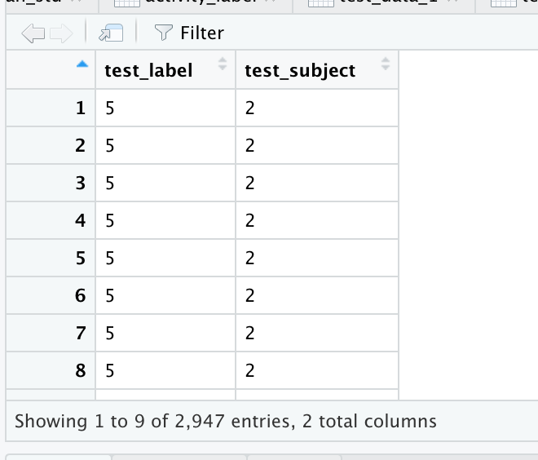

# Rename test_features column_names with feature_names

for(i in 1:561)

{

names(test_features)[names(test_features) == colnames(test_features[i])] <- features_name[i]

}

View(test features)

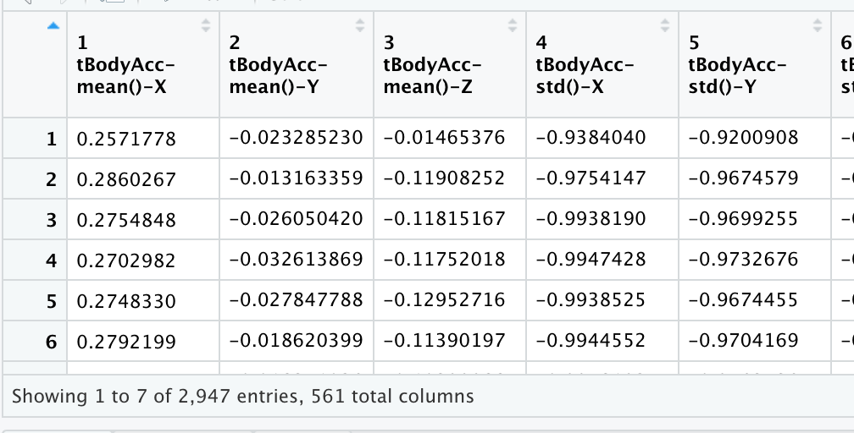

# Merges the training and the test sets to create one data set.

#

# Create a new data frame test_data_ 1 for the merge

# Merge train_data with train_features

train_data_1 <- data.frame(train_data, train_features)

# Merge test_data with test_features

test_data_1 <- data.frame(test_data, test_features)

# All columns must have same simple name to merge

names(test_data_1)[names(test_data_1) == 'test_label'] <- 'label'

names(test_data_1)[names(test_data_1) == 'test_subject'] <- 'subject'

View(test_data1)

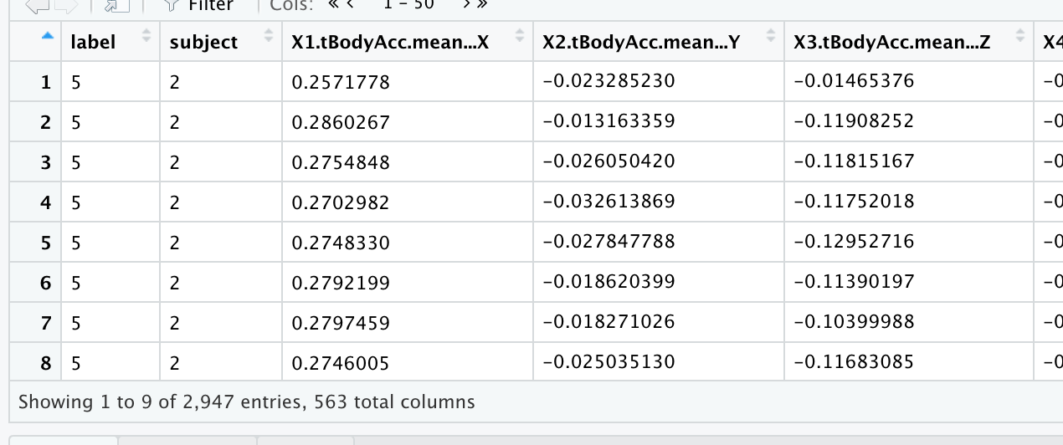

names(train_data_1)[names(train_data_1) == 'train_label'] <- 'label'

names(train_data_1)[names(train_data_1) == 'train_subject'] <- 'subject'

View(train_data1)

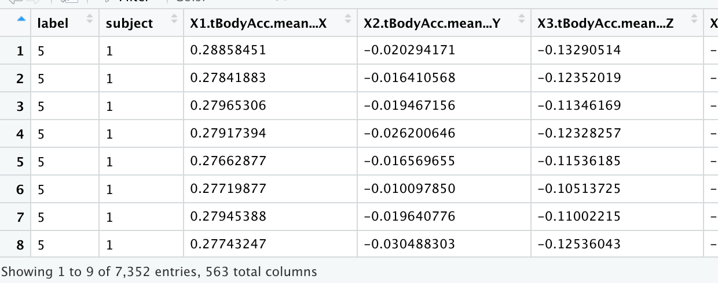

# Merge both test and train data

merge_data <- rbind(test_data_1, train_data_1)

View(merge_data)

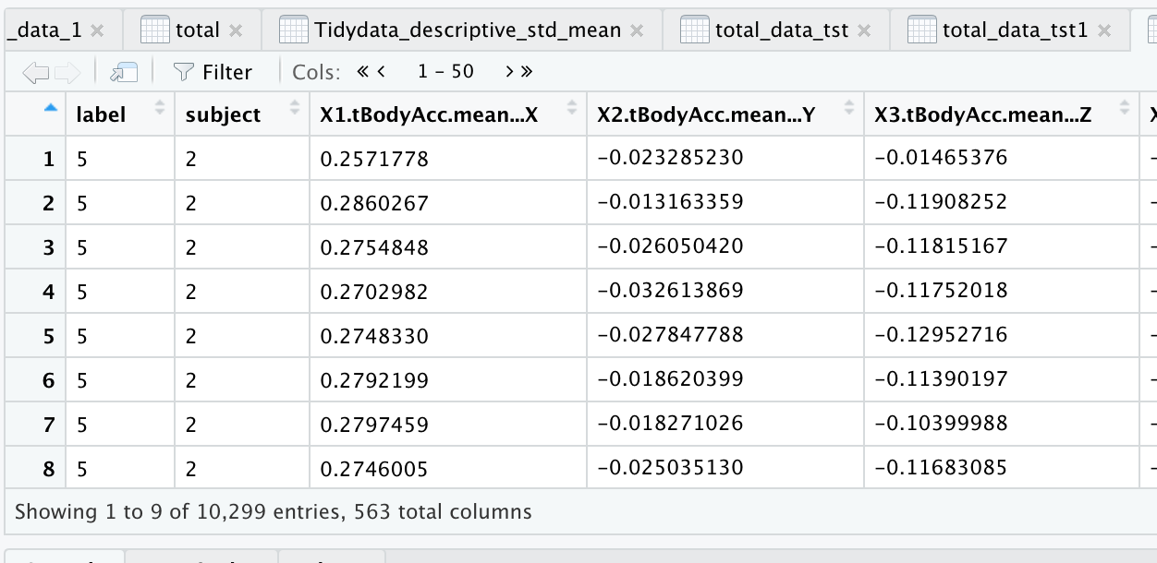

# Step 2 Extracts only the measurements on the mean and standard deviation for each measurement.

merge_data_mean_std<-select(merge_data, label, subject, contains("mean"), contains("std"))

View(merge_data_mean_std)

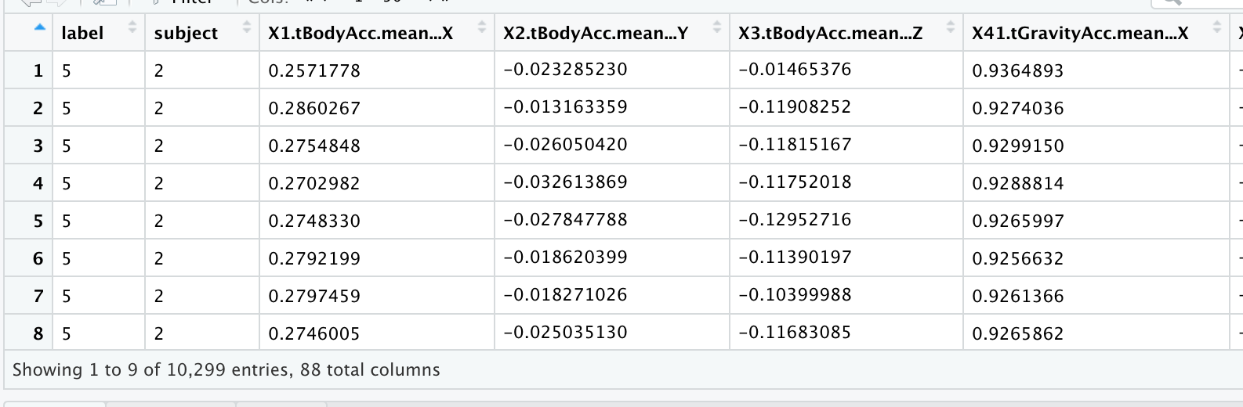

# Step 3 Uses descriptive activity names to name the activities in the data set

activity_label<- read.table("UCI HAR Dataset/activity_labels.txt", col.names = c("code", "activity"))

View(activity_label)

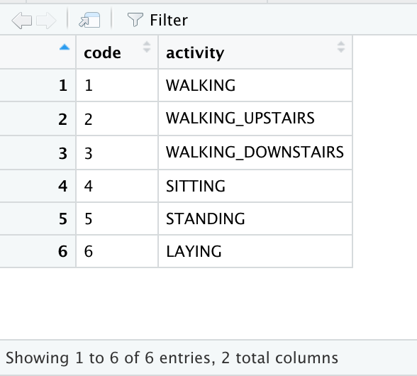

# Include activity label instead of numbers

merge_data_mean_std$label <- activity_label[merge_data_mean_std$label, 2]

View(merge_data_mean_std)

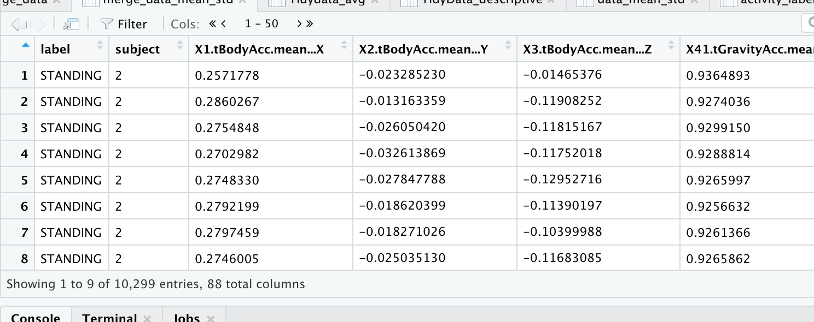

# Step 4 Appropriately labels the data set with descriptive variable names

# Rename label por activity type

names(merge_data_mean_std)[1] = "activity_type"

names(merge_data_mean_std)<-gsub("Mag", "_magnitude_", names(merge_data_mean_std))

names(merge_data_mean_std)<-gsub("Acc", "_accelerometer_", names(merge_data_mean_std))

names(merge_data_mean_std)<-gsub("-std()", "standard", names(merge_data_mean_std), ignore.case = TRUE)

names(merge_data_mean_std)<-gsub("Gyro", "_gyroscope_", names(merge_data_mean_std))

names(merge_data_mean_std)<-gsub("BodyBody", "_body_", names(merge_data_mean_std))

names(merge_data_mean_std)<-gsub("^t", "_time_", names(merge_data_mean_std))

names(merge_data_mean_std)<-gsub("^f", "_frequency_", names(merge_data_mean_std))

names(merge_data_mean_std)<-gsub("tBody", "_time_body_", names(merge_data_mean_std))

names(merge_data_mean_std)<-gsub("-freq()", "frequency", names(merge_data_mean_std), ignore.case = TRUE)

names(merge_data_mean_std)<-gsub("Acc", "_accelerometer_", names(merge_data_mean_std))

names(merge_data_mean_std)<-gsub("Acc.", "_accelerometer_", names(merge_data_mean_std))

names(merge_data_mean_std)<-gsub(".std()", "standard", names(merge_data_mean_std), ignore.case = TRUE)

View(merge_data_mean_std)

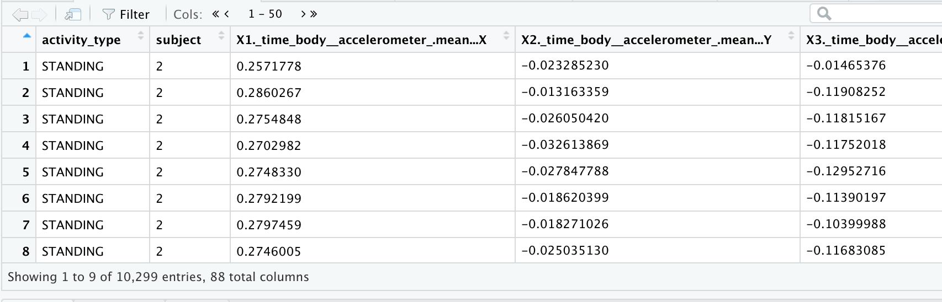

# Step 5 From the data set in step 4, creates a second, independent tidy data set with the average of each variable for each activity and each subject.

merge_data_mean_std_AVERAGE<-group_by(merge_data_mean_std, activity_type, subject) %>% summarise_all(funs(mean))

# Warning message:

# funs() is soft deprecated as of dplyr 0.8.0

# Please use a list of either functions or lambdas:

# Simple named list:

# list(mean = mean, median = median)

#

# Auto named with `tibble::lst()`:

# tibble::lst(mean, median)

#

# Using lambdas

# list(~ mean(., trim = .2), ~ median(., na.rm = TRUE))

# This warning is displayed once per session.

View(merge_data_mean_std_AVERAGE)

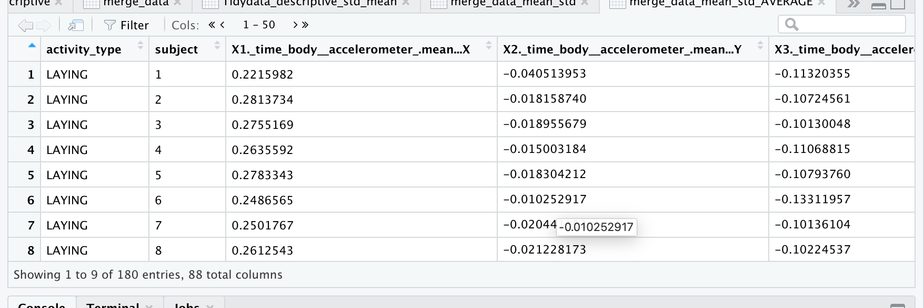

# Write data data out

write.table(merge_data_mean_std_AVERAGE, "FinalData.txt", row.name=FALSE)

# end

> str(merge_data_mean_std_AVERAGE)

Classes ‘grouped_df’, ‘tbl_df’, ‘tbl’ and 'data.frame': 180 obs. of 88 variables:

$ activity_type : Factor w/ 6 levels "LAYING","SITTING",..: 1 1 1 1 1 1 1 1 1 1 ...

$ subject : int 1 2 3 4 5 6 7 8 9 10 ...

$ X1._time_body__accelerometer_.mean...X : num 0.222 0.281 0.276 0.264 0.278 ...

$ X2._time_body__accelerometer_.mean...Y : num -0.0405 -0.0182 -0.019 -0.015 -0.0183 ...

$ X3._time_body__accelerometer_.mean...Z : num -0.113 -0.107 -0.101 -0.111 -0.108 ...

$ X41.tGravity_accelerometer_.mean...X : num -0.249 -0.51 -0.242 -0.421 -0.483 ...

$ X42.tGravity_accelerometer_.mean...Y : num 0.706 0.753 0.837 0.915 0.955 ...

$ X43.tGravity_accelerometer_.mean...Z : num 0.446 0.647 0.489 0.342 0.264 ...

$ X81._time_body__accelerometer_Jerk.mean...X : num 0.0811 0.0826 0.077 0.0934 0.0848 ...

$ X82._time_body__accelerometer_Jerk.mean...Y : num 0.00384 0.01225 0.0138 0.00693 0.00747 ...

$ X83._time_body__accelerometer_Jerk.mean...Z : num 0.01083 -0.0018 -0.00436 -0.00641 -0.00304 ...

$ X121._time_body__gyroscope_.mean...X : num -0.01655 -0.01848 -0.02082 -0.00923 -0.02189 ...

$ X122._time_body__gyroscope_.mean...Y : num -0.0645 -0.1118 -0.0719 -0.093 -0.0799 ...

$ X123._time_body__gyroscope_.mean...Z : num 0.149 0.145 0.138 0.17 0.16 ...

$ X161._time_body__gyroscope_Jerk.mean...X : num -0.107 -0.102 -0.1 -0.105 -0.102 ...

$ X162._time_body__gyroscope_Jerk.mean...Y : num -0.0415 -0.0359 -0.039 -0.0381 -0.0404 ...

$ X163._time_body__gyroscope_Jerk.mean...Z : num -0.0741 -0.0702 -0.0687 -0.0712 -0.0708 ...

$ X201._time_body__accelerometer__magnitude_.mean.. : num -0.842 -0.977 -0.973 -0.955 -0.967 ...

$ X214.tGravity_accelerometer__magnitude_.mean.. : num -0.842 -0.977 -0.973 -0.955 -0.967 ...

$ X227._time_body__accelerometer_Jerk_magnitude_.mean.. : num -0.954 -0.988 -0.979 -0.97 -0.98 ...

$ X240._time_body__gyroscope__magnitude_.mean.. : num -0.875 -0.95 -0.952 -0.93 -0.947 ...

$ X253._time_body__gyroscope_Jerk_magnitude_.mean.. : num -0.963 -0.992 -0.987 -0.985 -0.986 ...

$ X266.fBody_accelerometer_.mean...X : num -0.939 -0.977 -0.981 -0.959 -0.969 ...

$ X267.fBody_accelerometer_.mean...Y : num -0.867 -0.98 -0.961 -0.939 -0.965 ...

$ X268.fBody_accelerometer_.mean...Z : num -0.883 -0.984 -0.968 -0.968 -0.977 ...

$ X294.fBody_accelerometer_.meanFreq...X : num -0.159 -0.146 -0.074 -0.274 -0.136 ...

$ X295.fBody_accelerometer_.meanFreq...Y : num 0.0975 0.2573 0.2385 0.3662 0.4665 ...

$ X296.fBody_accelerometer_.meanFreq...Z : num 0.0894 0.4025 0.217 0.2013 0.1323 ...

$ X345.fBody_accelerometer_Jerk.mean...X : num -0.957 -0.986 -0.981 -0.979 -0.983 ...

$ X346.fBody_accelerometer_Jerk.mean...Y : num -0.922 -0.983 -0.969 -0.944 -0.965 ...

$ X347.fBody_accelerometer_Jerk.mean...Z : num -0.948 -0.986 -0.979 -0.975 -0.983 ...

$ X373.fBody_accelerometer_Jerk.meanFreq...X : num 0.132 0.16 0.176 0.182 0.24 ...

$ X374.fBody_accelerometer_Jerk.meanFreq...Y : num 0.0245 0.1212 -0.0132 0.0987 0.1957 ...

$ X375.fBody_accelerometer_Jerk.meanFreq...Z : num 0.0244 0.1906 0.0448 0.077 0.0917 ...

$ X424.fBody_gyroscope_.mean...X : num -0.85 -0.986 -0.97 -0.967 -0.976 ...

$ X425.fBody_gyroscope_.mean...Y : num -0.952 -0.983 -0.978 -0.972 -0.978 ...

$ X426.fBody_gyroscope_.mean...Z : num -0.909 -0.963 -0.962 -0.961 -0.963 ...

$ X452.fBody_gyroscope_.meanFreq...X : num -0.00355 0.10261 -0.08222 -0.06609 -0.02272 ...

$ X453.fBody_gyroscope_.meanFreq...Y : num -0.0915 0.0423 -0.0267 -0.5269 0.0681 ...

$ X454.fBody_gyroscope_.meanFreq...Z : num 0.0105 0.0553 0.1477 0.1529 0.0414 ...

$ X503.fBody_accelerometer__magnitude_.mean.. : num -0.862 -0.975 -0.966 -0.939 -0.962 ...

$ X513.fBody_accelerometer__magnitude_.meanFreq.. : num 0.0864 0.2663 0.237 0.2417 0.292 ...

$ X516.f_body__accelerometer_Jerk_magnitude_.mean.. : num -0.933 -0.985 -0.976 -0.962 -0.977 ...

$ X526.f_body__accelerometer_Jerk_magnitude_.meanFreq.. : num 0.266 0.342 0.239 0.274 0.197 ...

$ X529.f_body__gyroscope__magnitude_.mean.. : num -0.862 -0.972 -0.965 -0.962 -0.968 ...

$ X539.f_body__gyroscope__magnitude_.meanFreq.. : num -0.1398 0.0186 -0.0229 -0.2599 0.1024 ...

$ X542.f_body__gyroscope_Jerk_magnitude_.mean.. : num -0.942 -0.99 -0.984 -0.984 -0.985 ...

$ X552.f_body__gyroscope_Jerk_magnitude_.meanFreq.. : num 0.1765 0.2648 0.1107 0.2029 0.0247 ...

$ X555.angle._time_body__accelerometer_Mean.gravity. : num 0.02137 0.00579 0.0179 -0.00236 0.02121 ...

$ X556.angle._time_body__accelerometer_JerkMean..gravityMean.: num 0.00306 -0.00636 0.01665 -0.0155 0.05536 ...

$ X557.angle._time_body__gyroscope_Mean.gravityMean. : num -0.00167 0.06529 0.04559 0.00713 -0.00581 ...

$ X558.angle._time_body__gyroscope_JerkMean.gravityMean. : num 0.0844 -0.0294 0.0317 0.0367 -0.0344 ...

$ X559.angle.X.gravityMean. : num 0.427 0.617 0.424 0.553 0.599 ...

$ X560.angle.Y.gravityMean. : num -0.52 -0.52 -0.63 -0.763 -0.825 ...

$ X561.angle.Z.gravityMean. : num -0.352 -0.479 -0.346 -0.23 -0.168 ...

$ X4._time_body__accelerometer_standard...X : num -0.928 -0.974 -0.983 -0.954 -0.966 ...

$ X5._time_body__accelerometer_standard...Y : num -0.837 -0.98 -0.962 -0.942 -0.969 ...

$ X6._time_body__accelerometer_standard...Z : num -0.826 -0.984 -0.964 -0.963 -0.969 ...

$ X44.tGravity_accelerometer_standard...X : num -0.897 -0.959 -0.983 -0.921 -0.946 ...

$ X45.tGravity_accelerometer_standard...Y : num -0.908 -0.988 -0.981 -0.97 -0.986 ...

$ X46.tGravity_accelerometer_standard...Z : num -0.852 -0.984 -0.965 -0.976 -0.977 ...

$ X84._time_body__accelerometer_Jerkstandard...X : num -0.958 -0.986 -0.981 -0.978 -0.983 ...

$ X85._time_body__accelerometer_Jerkstandard...Y : num -0.924 -0.983 -0.969 -0.942 -0.965 ...

$ X86._time_body__accelerometer_Jerkstandard...Z : num -0.955 -0.988 -0.982 -0.979 -0.985 ...

$ X124._time_body__gyroscope_standard...X : num -0.874 -0.988 -0.975 -0.973 -0.979 ...

$ X125._time_body__gyroscope_standard...Y : num -0.951 -0.982 -0.977 -0.961 -0.977 ...

$ X126._time_body__gyroscope_standard...Z : num -0.908 -0.96 -0.964 -0.962 -0.961 ...

$ X164._time_body__gyroscope_Jerkstandard...X : num -0.919 -0.993 -0.98 -0.975 -0.983 ...

$ X165._time_body__gyroscope_Jerkstandard...Y : num -0.968 -0.99 -0.987 -0.987 -0.984 ...

$ X166._time_body__gyroscope_Jerkstandard...Z : num -0.958 -0.988 -0.983 -0.984 -0.99 ...

$ X202._time_body__accelerometer__magnitude_standard.. : num -0.795 -0.973 -0.964 -0.931 -0.959 ...

$ X215.tGravity_accelerometer__magnitude_standard.. : num -0.795 -0.973 -0.964 -0.931 -0.959 ...

$ X228._time_body__accelerometer_Jerk_magnitude_standard.. : num -0.928 -0.986 -0.976 -0.961 -0.977 ...

$ X241._time_body__gyroscope__magnitude_standard.. : num -0.819 -0.961 -0.954 -0.947 -0.958 ...

$ X254._time_body__gyroscope_Jerk_magnitude_standard.. : num -0.936 -0.99 -0.983 -0.983 -0.984 ...

$ X269.fBody_accelerometer_standard...X : num -0.924 -0.973 -0.984 -0.952 -0.965 ...

$ X270.fBody_accelerometer_standard...Y : num -0.834 -0.981 -0.964 -0.946 -0.973 ...

$ X271.fBody_accelerometer_standard...Z : num -0.813 -0.985 -0.963 -0.962 -0.966 ...

$ X348.fBody_accelerometer_Jerkstandard...X : num -0.964 -0.987 -0.983 -0.98 -0.986 ...

$ X349.fBody_accelerometer_Jerkstandard...Y : num -0.932 -0.985 -0.971 -0.944 -0.966 ...

$ X350.fBody_accelerometer_Jerkstandard...Z : num -0.961 -0.989 -0.984 -0.98 -0.986 ...

$ X427.fBody_gyroscope_standard...X : num -0.882 -0.989 -0.976 -0.975 -0.981 ...

$ X428.fBody_gyroscope_standard...Y : num -0.951 -0.982 -0.977 -0.956 -0.977 ...

$ X429.fBody_gyroscope_standard...Z : num -0.917 -0.963 -0.967 -0.966 -0.963 ...

$ X504.fBody_accelerometer__magnitude_standard.. : num -0.798 -0.975 -0.968 -0.937 -0.963 ...

$ X517.f_body__accelerometer_Jerk_magnitude_standard.. : num -0.922 -0.985 -0.975 -0.958 -0.976 ...

$ X530.f_body__gyroscope__magnitude_standard.. : num -0.824 -0.961 -0.955 -0.947 -0.959 ...

$ X543.f_body__gyroscope_Jerk_magnitude_standard.. : num -0.933 -0.989 -0.983 -0.983 -0.983 ...

- attr(*, "groups")=Classes ‘tbl_df’, ‘tbl’ and 'data.frame': 6 obs. of 2 variables:

..$ activity_type: Factor w/ 6 levels "LAYING","SITTING",..: 1 2 3 4 5 6

..$ .rows :List of 6

.. ..$ : int 1 2 3 4 5 6 7 8 9 10 ...

.. ..$ : int 31 32 33 34 35 36 37 38 39 40 ...

.. ..$ : int 61 62 63 64 65 66 67 68 69 70 ...

.. ..$ : int 91 92 93 94 95 96 97 98 99 100 ...

.. ..$ : int 121 122 123 124 125 126 127 128 129 130 ...

.. ..$ : int 151 152 153 154 155 156 157 158 159 160 ...

..- attr(*, ".drop")= logi TRUE